JakSAFE Data Preparation Documentation

Date: 23 June 2016

Prepared for:





|  |  |
| --- | --- |
|  |  |
| **geo.jpg** | **Geo Enviro Omega**  Office8, Level 18-A Sudirman Central Business District  Jl. Jendral Sudirman Kav. 52-53, Jakarta Selatan 12190 Indonesia  services@geo.co.id | +62 21 9797 8673 | www.geo.co.id |

Table of Content

Table of Content 2

List of Figure 2

List of Table 3

Revision History 3

1. Introduction 4

1.1. Project Background 4

1.2. General Overview 4

2. Tools 4

2.1. Data 4

2.2. Database Software 5

2.3. GIS Software 8

3. Hazard Data 10

3.1. Data 10

3.2. Process 11

4. Exposure Data 13

4.1. Data 13

4.2. Building Exposure 14

4.3. Road Exposure 20

5. Making Database 25

5.1. Data 25

5.2. JakSAFE Database Struchture 26

5.3. Deploy Main Database 27

5.4. Pre Calculation Database 30

# List of Figure

Figure 1 Deployment Scheme of JakSAFE database Illustration 4

Figure 2 Installation PostgreSQL 5

Figure 3 PostGIS Installation 6

Figure 4 Postgis Create Spatial Database 6

Figure 5 Database Connection 7

Figure 6 PGAdmin Installation 8

Figure 7 Enabling PostGIS Extension 8

Figure 8 QGIS Installation 9

Figure 9 Add Database Connection to QGIS 9

Figure 10 Database Setting Connection 10

Figure 11 Table for QGIS Environment 11

Figure 12 Output Hazard Shapefile 13

Figure 13 Add Vector Data 15

Figure 14 Open Graphical Modeler 15

Figure 15 Open Model 16

Figure 16 Running Model 17

Figure 17 Open Database 18

Figure 18 Open Database Script 18

Figure 19 Execute Query 19

Figure 20 Backup FIle 19

Figure 21 Run Backup 20

Figure 22 Add Vector Layer 21

Figure 23 Open Graphical Modeler 21

Figure 24 Open Model 22

Figure 25 Run Model 22

Figure 26 Open Database 23

Figure 27 Open Database Script 23

Figure 28 Executing Query 24

Figure 29 Backup Table 24

Figure 30 Run Backup 25

Figure 31 Add PostgreSQL Server Connection 27

Figure 32 Setting Server Connection 28

Figure 33 Restore Database in Server 28

Figure 34 Run Restore 29

Figure 35 Import CSV 29

# List of Table

Table 1 Data Needed for Tools Installation 4

Table 2 Data for Making Hazard 10

Table 3 Parameter for Contour Delineation Script 11

Table 4 Data for Making Exposure 13

Table 5 Data for Deploying Database 24

Table 6 Database Struchture 25

Revision History

|  |  |  |  |
| --- | --- | --- | --- |
| **No.** | **Editor** | **Version** | **Description** |
| 1 | **Mohammad Fadli** | 1.0 | Initiation |
| 2 | **Mia Renauly** | 1.1 | Content writing |

1. Introduction
   1. Project Background

Data is playing significant role for disaster management, it will help decision maker to analyze the situation on their decision making process. Therefore, the more detail your data, the better result you will delivered. JakSAFE is a quick estimation tools designed to estimate Damage and Loss due to Flood disaster in Jakarta. Estimating Damage and Loss is a complex process and need sufficient information and appropriate methodology.

JakSAFE Team has collected data for JakSAFE input which classified into: hazard, exposure other supporting information. With those data we build an assumption to precede the calculation.

This document is will elaborate the detail of methodology and science behind the estimation of JakSAFE Application. It will describe the use, granularity, resolution, year updated, assumption and other information parameter which is needed by JakSAFE. Mostly the the data obtained from Disaster Management Agency of Jakarta, other government institutions, private institutions, associations, and other agencies.

JakSAFE deliver the damage and loss calculation value in Rupiahs. The damage and loss value also can be drilled down until RW Boundary, the smallest administrative level. JakSAFE data processing involving Economic Valuation, Geographic Information System, and also Database Management. For further detail of the whole process will be discussed on next chapter.

This page also dedicated to all researchers in the world which focus on Damage & Loss Assessment due to flood and challenge them to contribute and involve on the improvement of JakSAFE. Since the beginning of the project, JakSAFE is Free and Open Source Software (FOSS) project, and published under the GPL V3 license. Everybody are welcome to put Inputs on design, User Interfaces, architecture, data, and other this that can be obtained.

* 1. General Overview

Data is playing significant role for disaster management, it will help decision maker to analyze the situation on their decision making process. Therefore, the more detail your data, the better result you will delivered. JakSAFE is a quick estimation tools designed to estimate Damage and Loss due to Flood disaster in Jakarta. Estimating Damage and Loss is a complex process and need sufficient information and appropriate methodology.

JakSAFE Team has collected data for JakSAFE input which classified into: hazard, exposure other supporting information. With those data we build an assumption to precede the calculation.

This document is will elaborate the detail making JakSAFE database. It will describe the tools and technic used to produce JakSAFE database. We also providing the sample database, so public can try to make the database using this guideline, on their own. In general the database component can break down into exposure, hazard, and damage and loss matrix. Then those three main database was processed into other associated database. This document consists of 4 part; JakSAFE Methodology, JakSAFE Data Preparation, JakSAFE Installation Guideline, and JakSAFE User Manual.

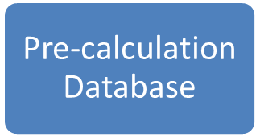

Figure 1 Deployment Scheme of JakSAFE database Illustration

1. Tools
   1. Data

Now download these softwares before we go into processing steps of JakSAFE database:

Table 1 Data Needed for Tools Installation

|  |  |  |
| --- | --- | --- |
| **Software** | **Download Link** | **Description** |
| QGIS (GIS Software) | [*https://www.qgis.org/en/site/forusers/download.html*](https://www.qgis.org/en/site/forusers/download.html) | *Choose QGIS standalone installer for your OS.* Choose whichever version you like, I am using QGIS 2.8.3 |
| PostgreSQL (Database Software) | http://www.enterprisedb.com/products-services-training/pgdownload | Object-relational database system. Use. Choose whichever version you like for your OS, I am using PostgreSQL v9.2 |
| PGAdmin (Database Software) | https://www.pgadmin.org/download/ | Graphical User Interface for PostgreSQL. Choose whichever version you like for you OS, I am using PGAdmin3 v1.2 |
| PostGIS (Database Software) | *http://postgis.net/install/* | Spatial and Geographic objects for PostgreSQL. Choose version that match with your Postgis v2.1.5 that match with my PostgreSQL v9.2 |

* 1. Database Software
* ***Open PostgreSQL installer*** > ***Click Next***until the installation process was done

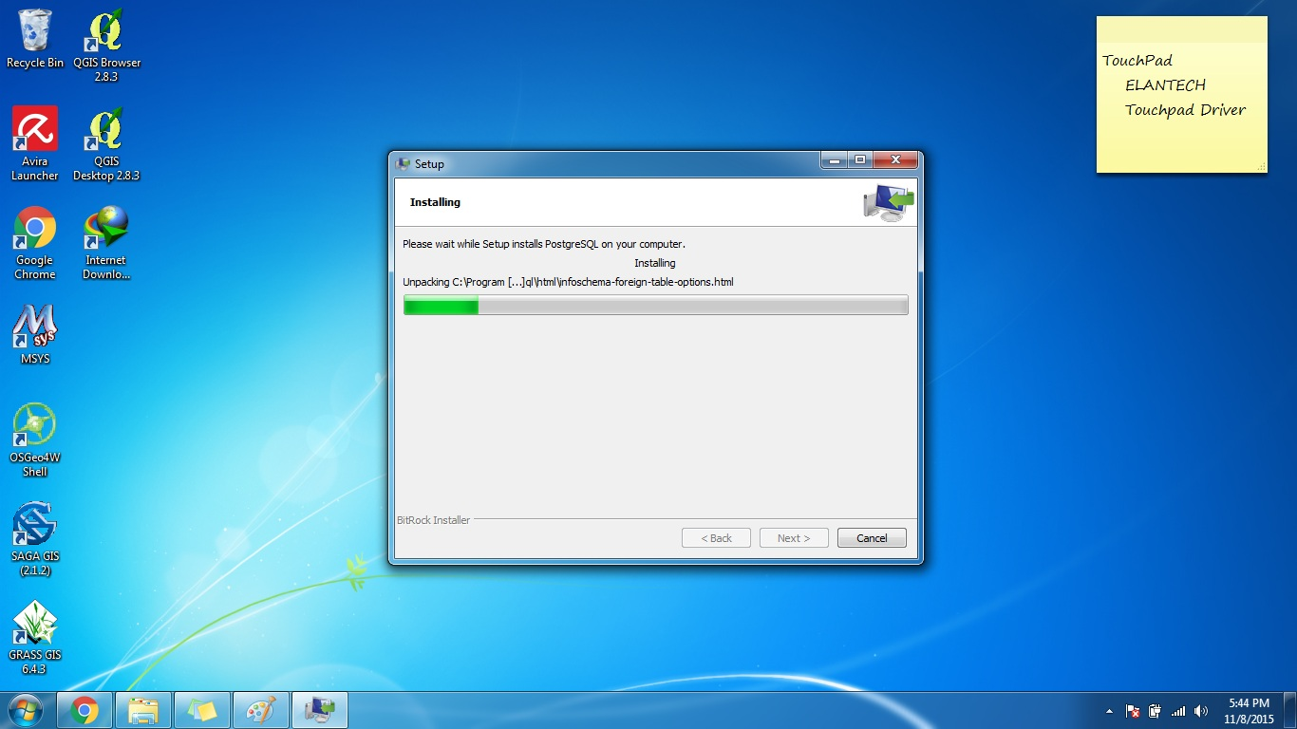

Figure 2 Installation PostgreSQL

* In the process, you will be asked to make a username and password

User: **postgres** (or anything you like)

Password: **password** (or anything you like)

* After PostgreSQL installed, run **postgis** ***installer*** > ***Click Next***until the installation process was done

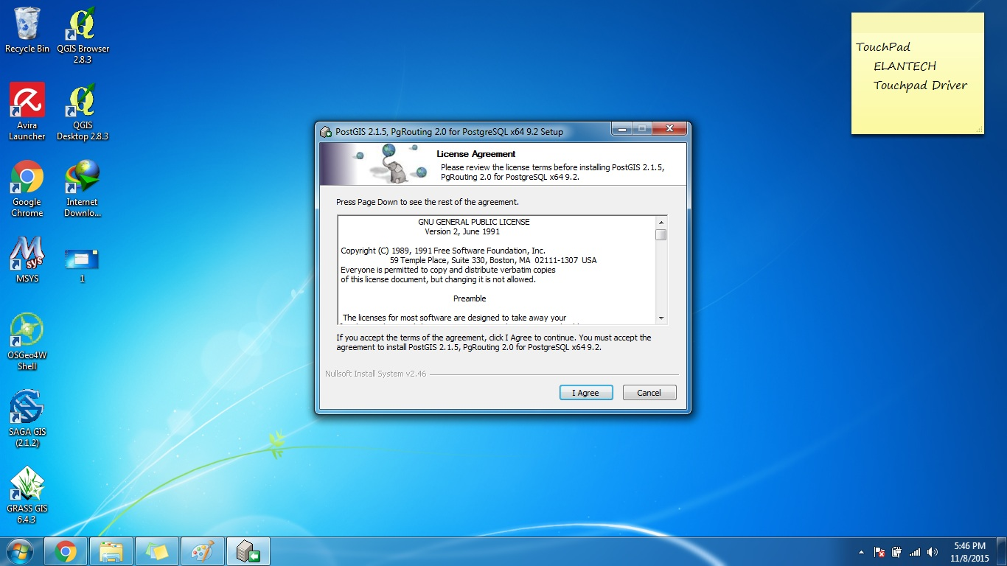

Figure 3 PostGIS Installation

* Then Choose ***Create Spatial Database.*** This was done to make a separate database for spatial file. This process will make default Database with name *postgis_21_sample*

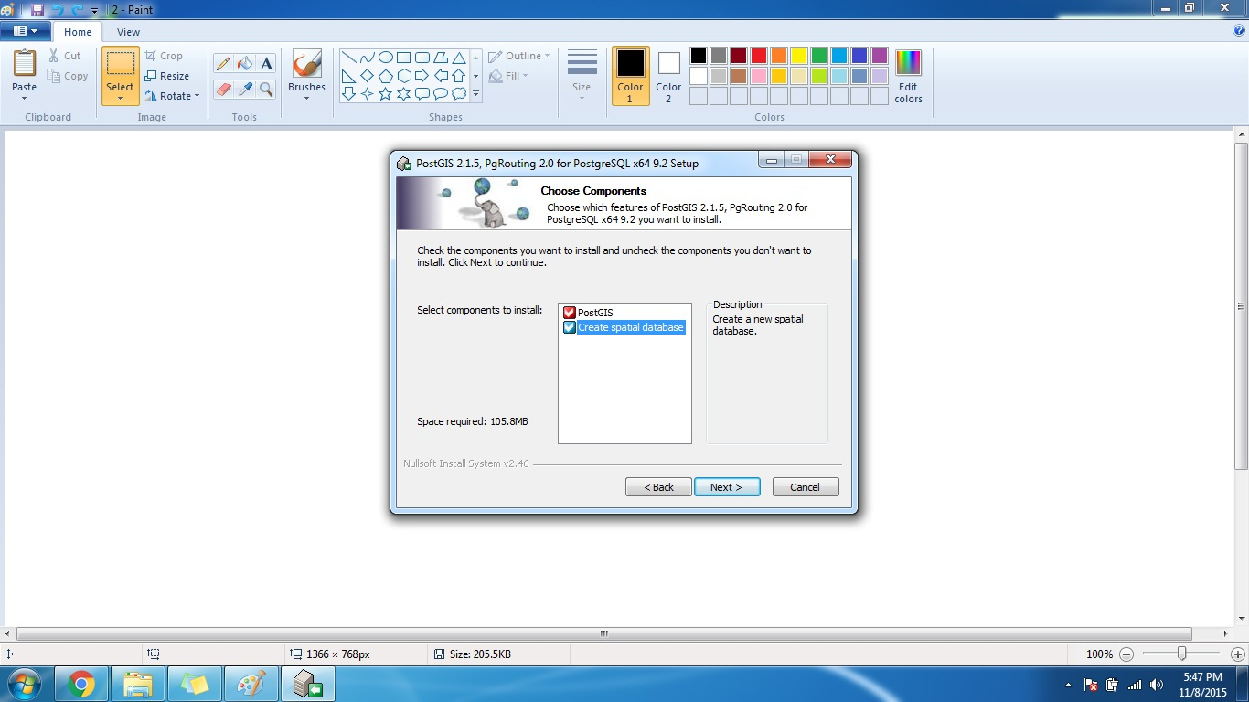

Figure 4 Postgis Create Spatial Database

* Type ***username and password*** of your **postgreSQL** > Then click ***Yes/Next*** until installation was done.

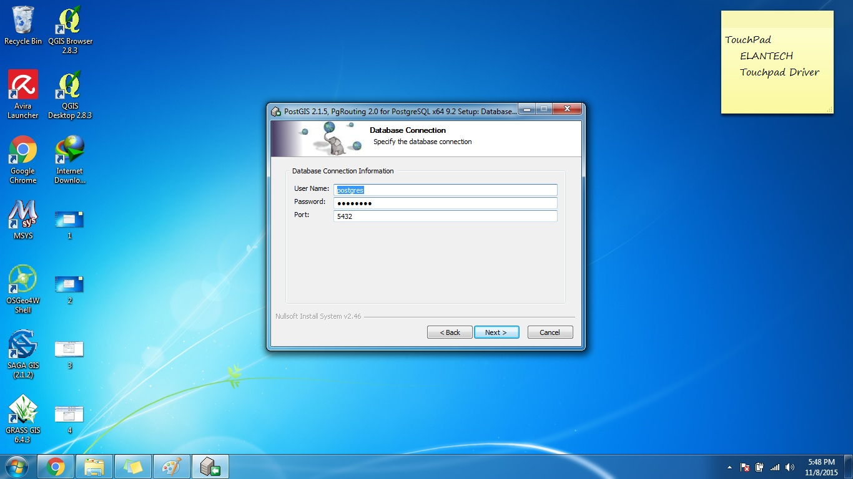

Figure 5 Database Connection

* And lastly, you need to install PGAdmin to complete the process of database installation. Run **PGAdmin installer** > ***Click Next*** until installation process is done.

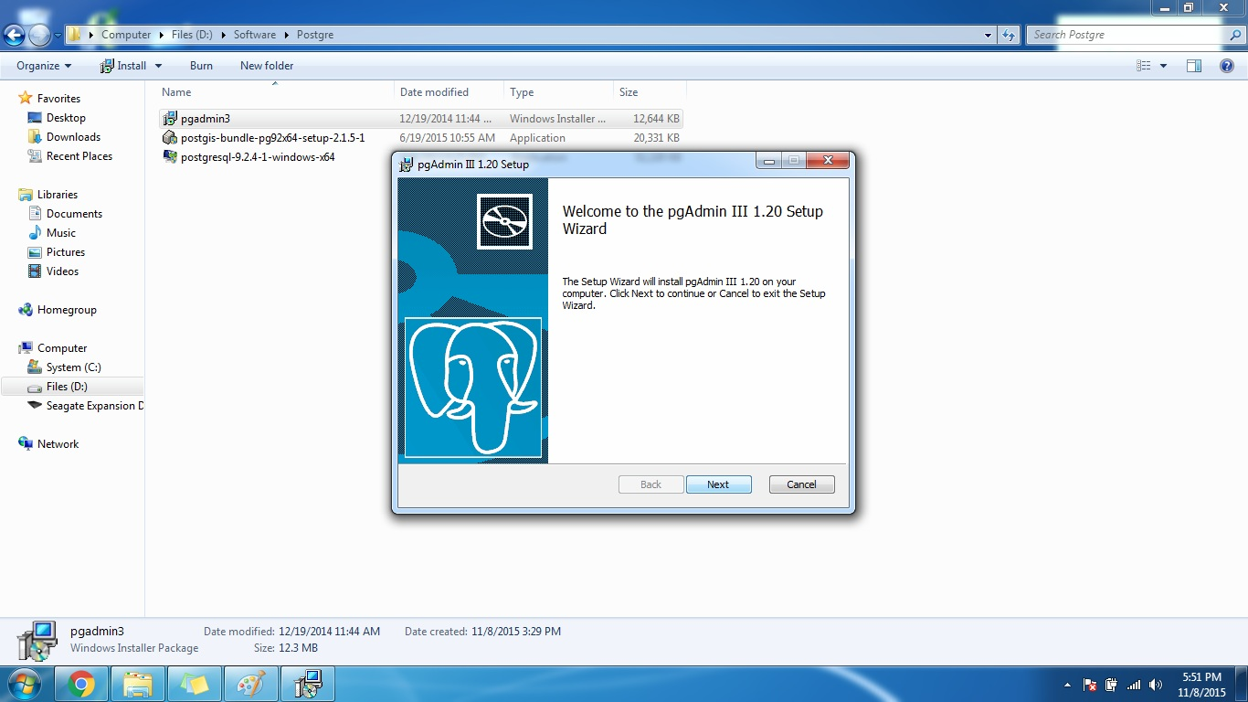

Figure 6 PGAdmin Installation

- Now that you have downloaded all the software above, make sure all of the service is running by opening **PgAdmin > PostgreSQL > PostGIS_21_Sample**. Then click on the query builder, that looks like these icons 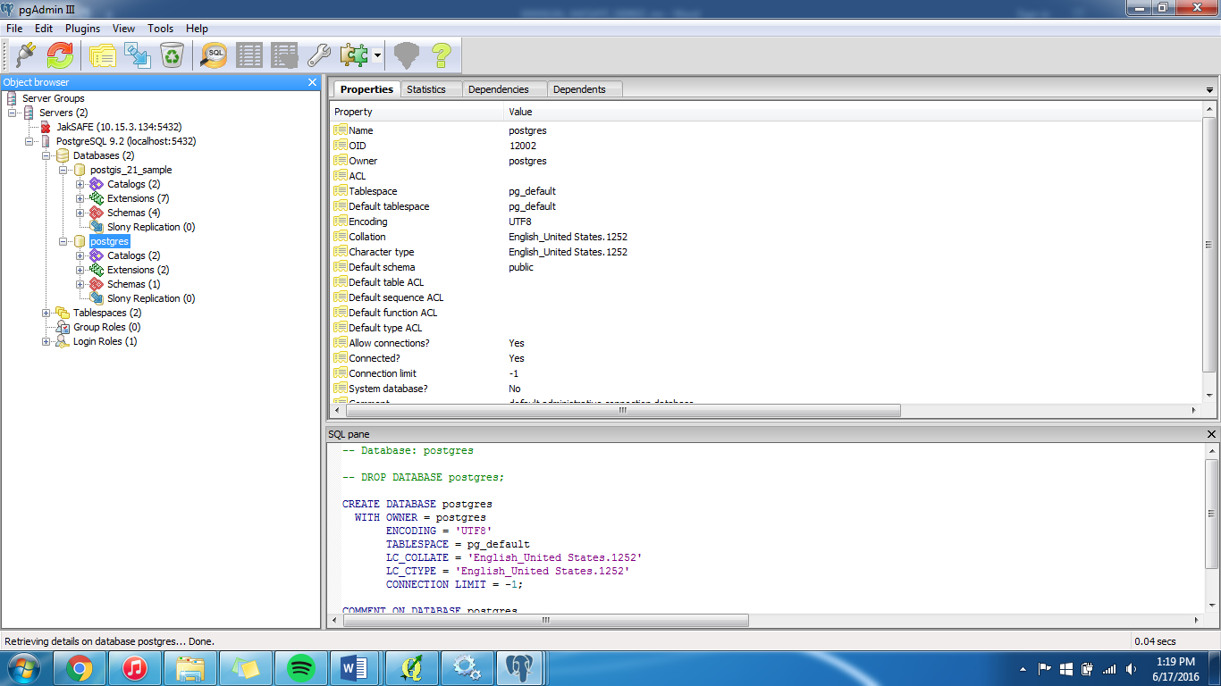. Then write “CREATE EXTENSION postgis” (without the quotation mark), then run it by pressing **F5** from keyboard. There should be a response like this picture below.

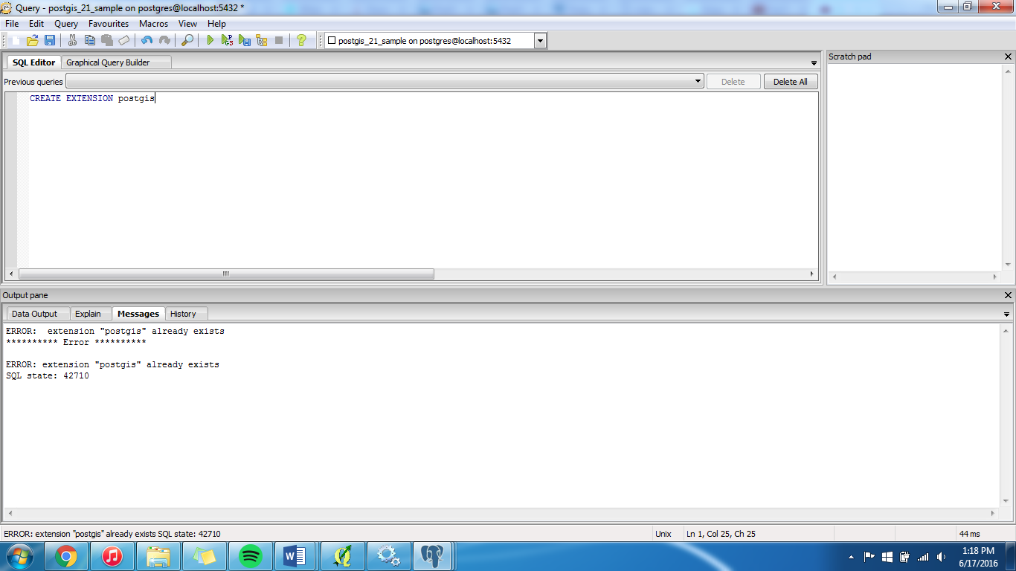

Figure 7 Enabling PostGIS Extension

# GIS Software

* ***Open QGIS Installer*** > ***Click Next*** until the installation process was done.

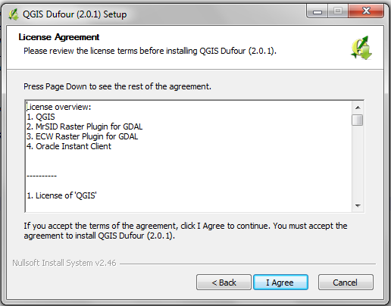

Figure 8 QGIS Installation

* Then open QGIS Desktop, and making connection between QGIS to database by clicking ***Add PostGIS Table*** toolbar like below:

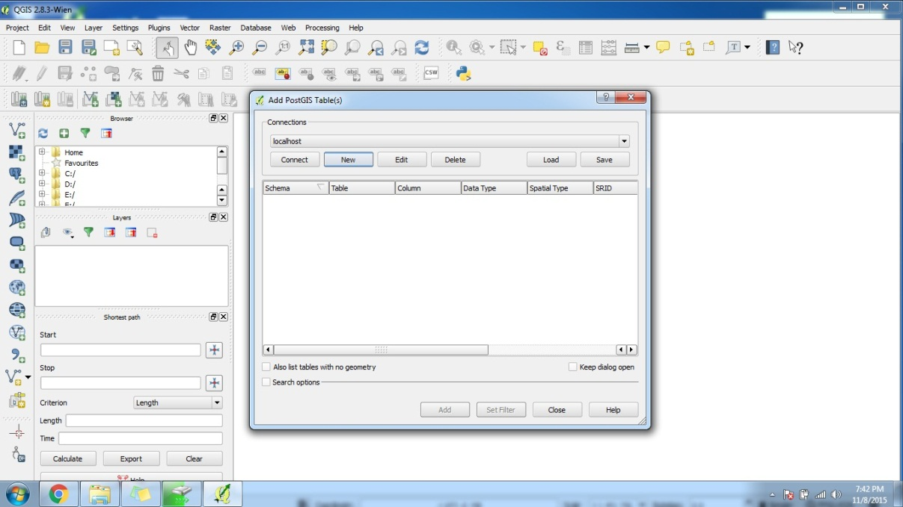

1. Click ***Add postgis table***

2. Click ***New***

Figure 9 Add Database Connection to QGIS

* Then change the setting connection of like table below

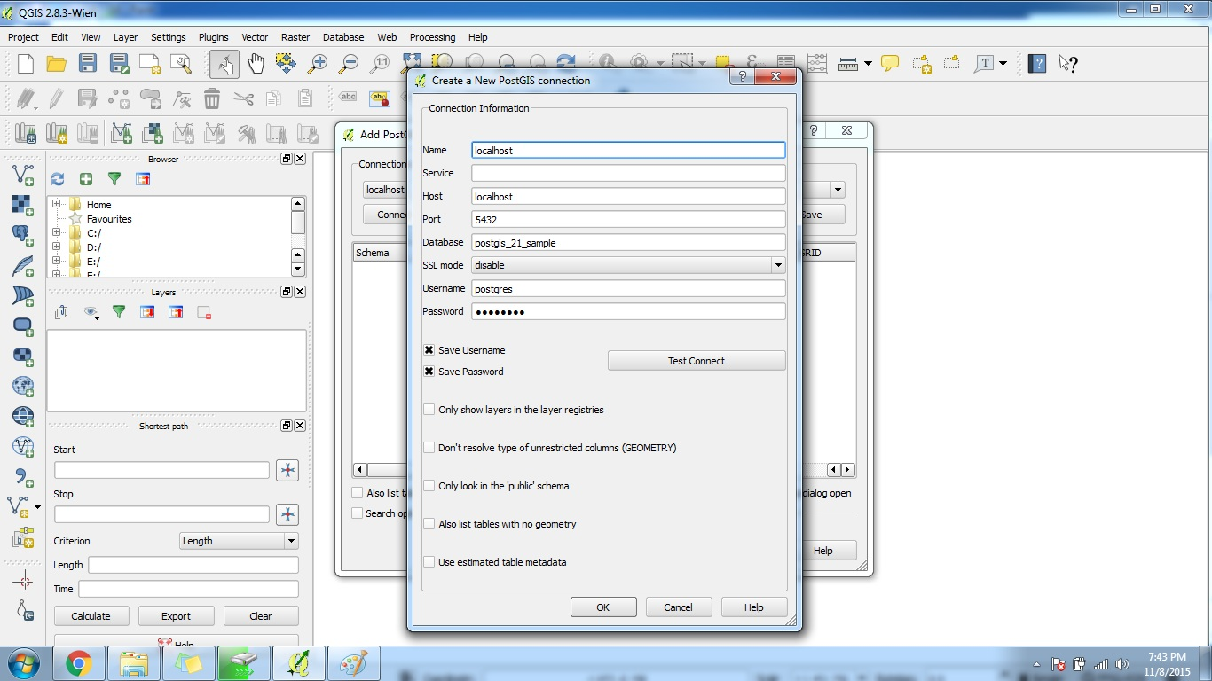

Click OK when done

Username and Password of Database

Database name

Figure 10 Database Setting Connection

* And finally your ***QGIS*** is connected with you local PostreSQL ***database*** (postgis_21_sample database)

1. Hazard Data
   1. Data

Now download these datasets to executing script for contour delineation process:

Table 2 Data for Making Hazard

|  |  |  |  |
| --- | --- | --- | --- |
| **Data** | **File Name** | **Description** | **Download Link** |
| Jakarta Digital Elevation Model (DEM) | jkt_2m.tif | On the real process of database making, we use DEM file with 2 meters of spatial resolution. However, because of data confidentiality, we only displaying DEM with 10 meters of spatial resolution | [*http://gis.bpbd.jakarta.go.id/layers/geonode%3Ajkt_20m*](http://gis.bpbd.jakarta.go.id/layers/geonode%3Ajkt_20m) |
| Jakarta RW Boundary Shapefile | boundary.shp |  | [*http://gis.bpbd.jakarta.go.id/layers/geonode%3Adki_rw_boundary*](http://gis.bpbd.jakarta.go.id/layers/geonode%3Adki_rw_boundary) |
| Jakarta River Shapefile | riverdki_polygon.shp |  | *http://gis.bpbd.jakarta.go.id/maps/276* |
| Modified Jakarta Digital Elevation Model (DEM) | Jkt_erase.tif | This is DEM file that has been erased by river polygon shapefile. You can modified DEM file by erasing the water body using river polygon shapefile. |  |

* 1. Process

To make sure this script will running correctly on Windows OS, you need to set the environment variable path of QGIS on Windows OS. To do that, you need to locate the directory where your QGIS Software installed, and then open folder named Bin, and copy the path location, in my case it was *C:\Program Files\QGIS Wien\bin.* Then put those path on the Environment Variable Properties.

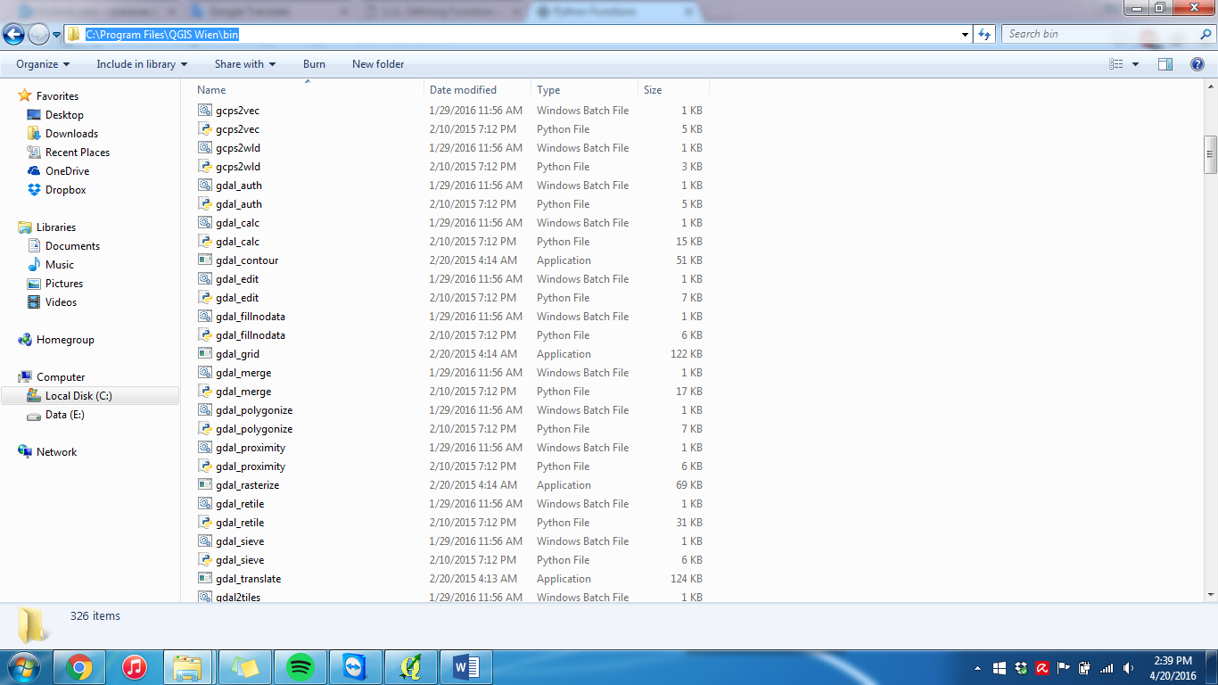

Location Path of QGIS Environment

Figure 11 Table for QGIS Environment

Now that the tools finally ready, we need to download the script from this link [*https://github.com/geoenvo/jaksafe-etc/blob/master/script_contour_delineation.py*](https://github.com/geoenvo/jaksafe-etc/blob/master/script_contour_delineation.py). After downloading the script, Open QGIS Software, then open those script on QGIS Python Console (Plugins Menu 🡪 Python Console). Now that the script was opened on QGIS Python Console, you need to adjusting the parameter to made those script working. The parameter was the directory location of input file and output folder, you can customize it for your own file, the parameter was:

Table 3 Parameter for Contour Delineation Script

|  |  |  |
| --- | --- | --- |
| **PARAMETER/VARIABLE NAME** | **DIRECTORY** | **DESCRIPTION** |
| BOUNDARY_SHP | **"E:/01 JakSAFE/09 PEMODELAN RW BANJIR QGIS/boundary.shp"** | Input shapefile (RW Boundary) |
| MASKING_FOLDER | **"E:/01 JakSAFE/09 PEMODELAN RW BANJIR QGIS/POLY RW/"** | Output of feature iteration (spliting feature from one shapefile) and going to be used as masking zone on Raster Masking Process |
| INPUT_RASTER | **"E:/01 JakSAFE/09 PEMODELAN RW BANJIR QGIS/RASTER/jkt_erase.tif"** | Raster DEM data input path that has been modified using river boundary shapefile |
| OUTPUT_MASKING | **"E:/01 JakSAFE/09 PEMODELAN RW BANJIR QGIS/MASK/"** | Path for output of Masking Raster Process |
| OUTPUT_RECLASS | **"E:/01 JakSAFE/09 PEMODELAN RW BANJIR QGIS/RECLASS/"** | Path for output of Raster Reclassification Process |
| OUTPUT_POLYGON | **"E:/01 JakSAFE/09 PEMODELAN RW BANJIR QGIS/POLYGON/"** | Path for output of Polygonize Raster Process |
| HAZARD | **"E:/01 JakSAFE/09 PEMODELAN RW BANJIR QGIS/hazard.shp"** | Output shapefile merge hazard (final) |

After customizing the parameters, you can run the script in QGIS Python Console, by opening **Plugin Menu on QGIS > Python Console.**

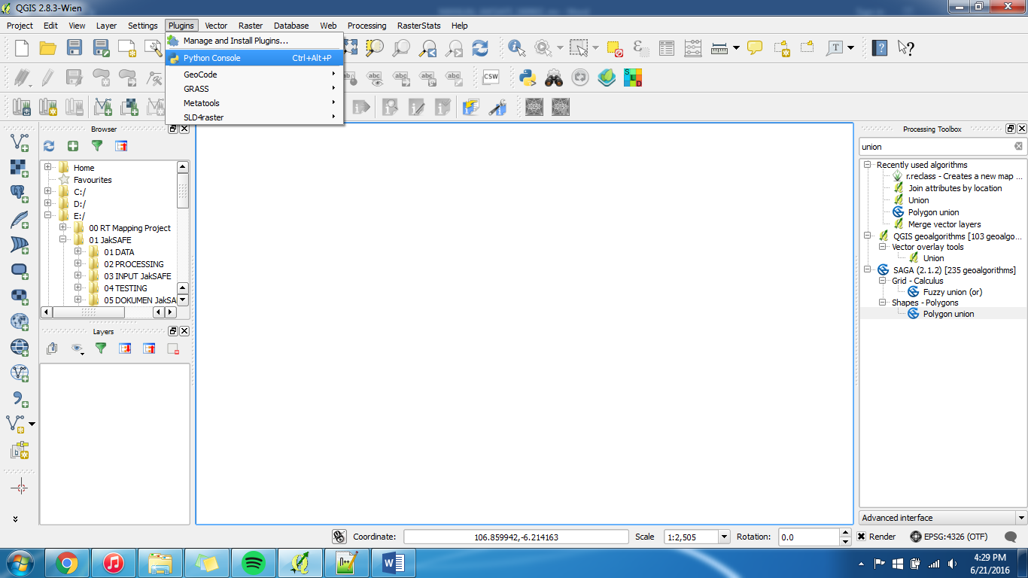

Then **Show the Editor tab on Python Console > Browse for the “COUNTOUR_DELINEATION” script > Then Run the script** like steps below:

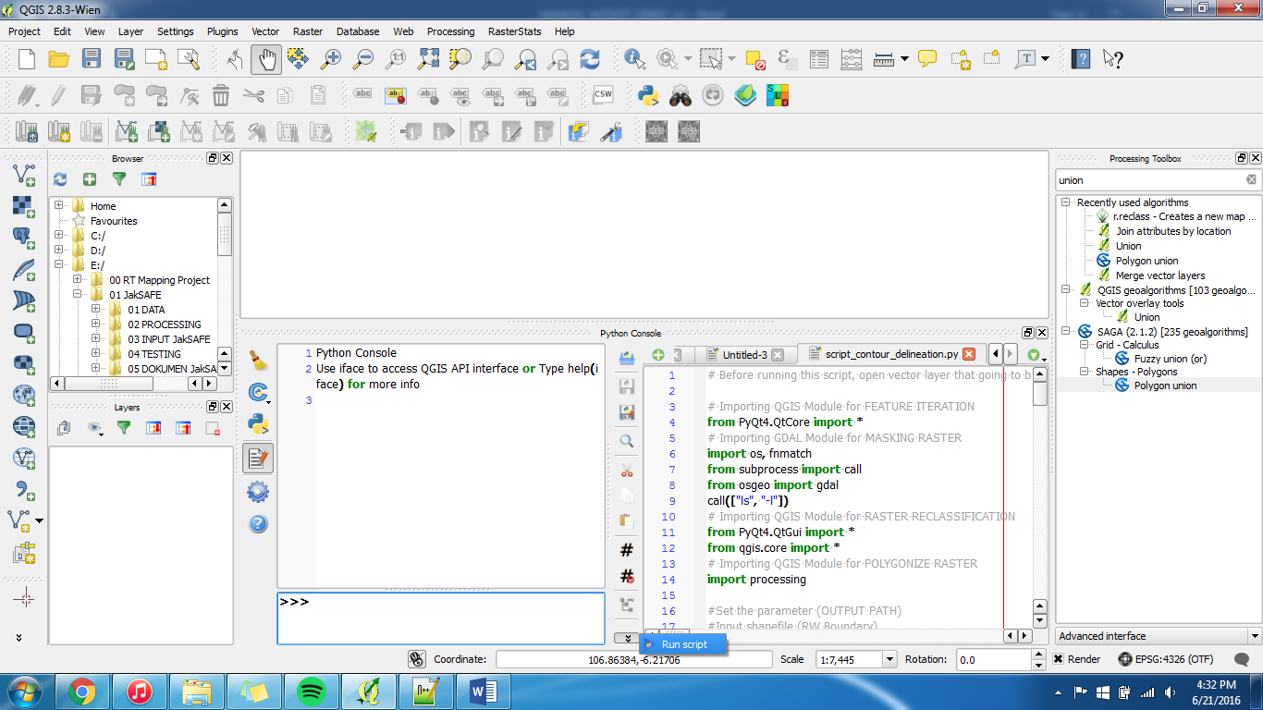

1. Show Editor

2. Browse Script

3. Run Script

Then check for the output file on HAZARD parameters folder (refer to the script) in your computer path. The final output was located in OUTPUT_SHAPEFILE directory. Trough all those process, you will get the final hazard file with flood category in the attribute file in one shapefile. Then give boundary information by running script_cleaning_hazard.py that can be downloaded in this link https://github.com/geoenvo/jaksafe-etc/blob/master/script_cleaning_hazard.py. Before running the script, set the parameter first like below:

Table 4 Parameter for Cleaning_Hazard Script

|  |  |  |
| --- | --- | --- |
| **PARAMETER/VARIABLE NAME** | **DIRECTORY** | **DESCRIPTION** |
| BOUNDARY_SHP | **"E:/01 JakSAFE/09 PEMODELAN RW BANJIR QGIS/boundary.shp"** | Input shapefile (RW Boundary) |
| RIVER_DKI | **"E:/01 JakSAFE/09 PEMODELAN RW BANJIR QGIS/riverdki_polygon.shp"** | Input shapefile (River Polygon) |
| OUTPUT_POLYGON | **"E:/01 JakSAFE/09 PEMODELAN RW BANJIR QGIS/POLYGON/"** | Path for output of Polygonize Raster Process |
| HAZARD | **"E:/01 JakSAFE/09 PEMODELAN RW BANJIR QGIS/hazard.shp"** | Output shapefile merge hazard |
| HAZARD_RIVER | **"E:/01 JakSAFE/09 PEMODELAN RW BANJIR QGIS/hazard_river.shp"** | Output shapefile for merging hazard with river polygon |
| HAZARD_FINAL | **"E:/01 JakSAFE/09 PEMODELAN RW BANJIR QGIS/hazard_final.shp"** | Output shapefile for merging hazard with boundary shapefile |

Then execute the script on QGIS python console, and after done, check for the output file on HAZARD_FINAL parameters folder (refer to the script) in your computer path. The final output was located in HAZARD_FINAL directory. Trough all those process, you will get the final hazard file with location and flood category in the attribute file.

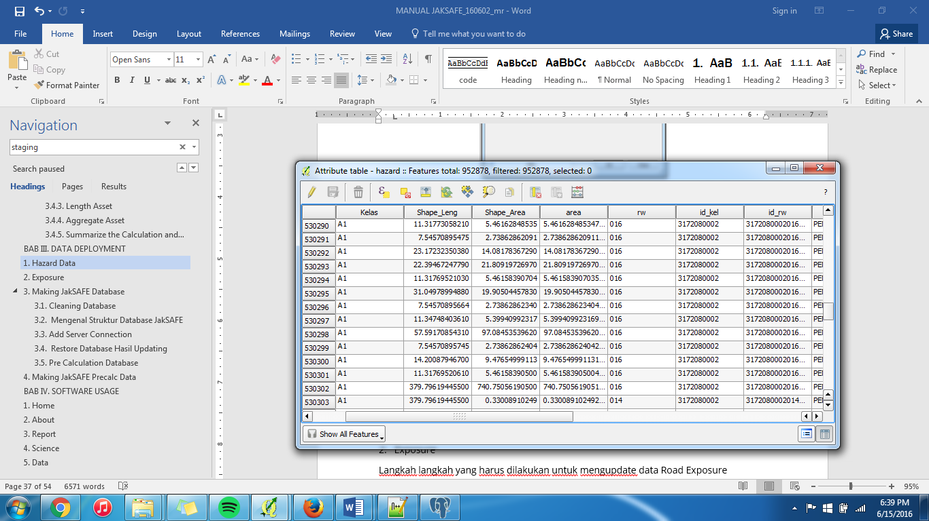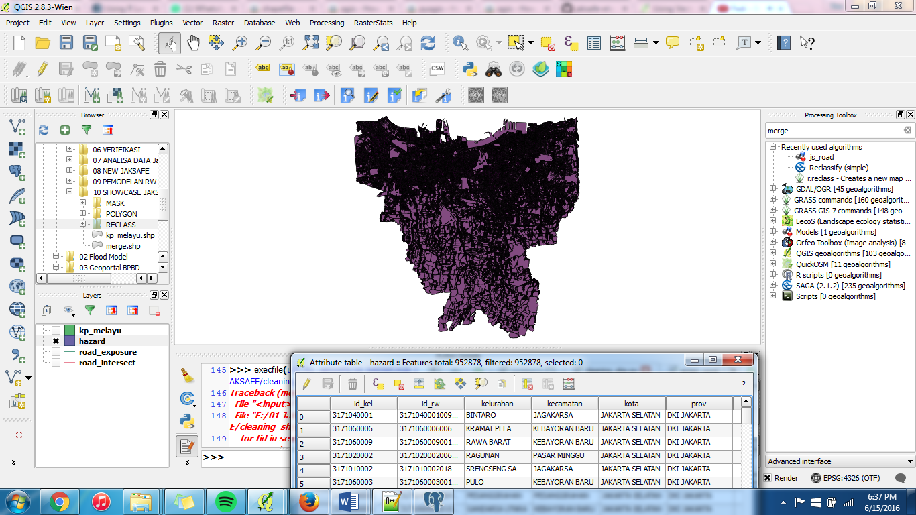

Figure 12 Output Hazard Shapefile

1. Exposure Data
   1. Data

Now we must have had these datasets from output of processes before and download some additional data:

Table 5 Data for Making Exposure

|  |  |  |  |
| --- | --- | --- | --- |
| **Data** | **File Name** | **Description** | **Download Link** |
| QGIS Graphical Modeler for Building Exposure | js_building.model |  | https://github.com/geoenvo/jaksafe-etc/blob/master/graphical_modeler |
| QGIS Graphical Modeler for Road Exposure | js_road.model |  | *https://github.com/geoenvo/jaksafe-etc/blob/master/graphical_modeler* |
| Hazard | hazard.shp | Output of making hazard data |  |
| Building exposure of JakSAFE | building_exposure.shp | Download the sample data (building exposure data of Jakarta pusat) and named the file to building_exposure | http://gis.bpbd.jakarta.go.id/search/?title__icontains=Exposure%20Jakarta%20Pusat&limit=100&offset=0 |
| Road exposure of JakSAFE | road_exposure.shp |  | http://gis.bpbd.jakarta.go.id/search/?title__icontains=Road%20Exposure&limit=100&offset=0 |
| SQL script for Building Exposure | js_building.sql |  | https://github.com/geoenvo/jaksafe-etc/tree/master/query_database |
| SQL script for Road Exposure | js_road.sql |  | *https://github.com/geoenvo/jaksafe-etc/tree/master/query_database* |

* 1. Building Exposure

The steps that has to be done to updating exposure data based on hazard data are:

* Open QGIS Software, then click **Add Vector Layer > and browse** ***hazard.shp dan building_exposure.shp > Then click open***

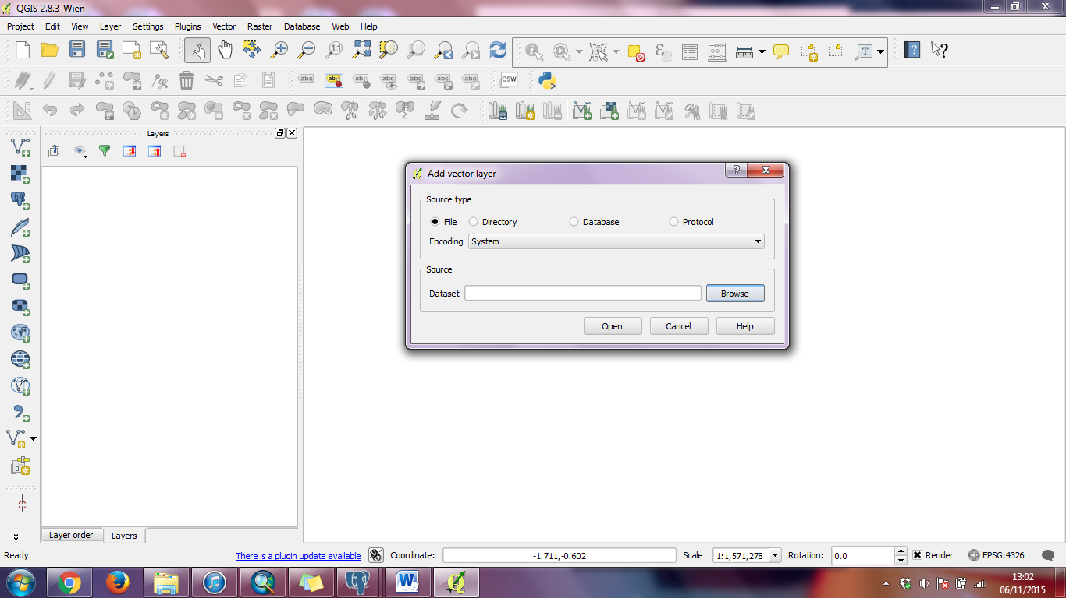

Add vector layer

Figure 13 Add Vector Data

* Then on Menu bar, open ***PROCESSING*** > ***GRAPHICAL MODELER***

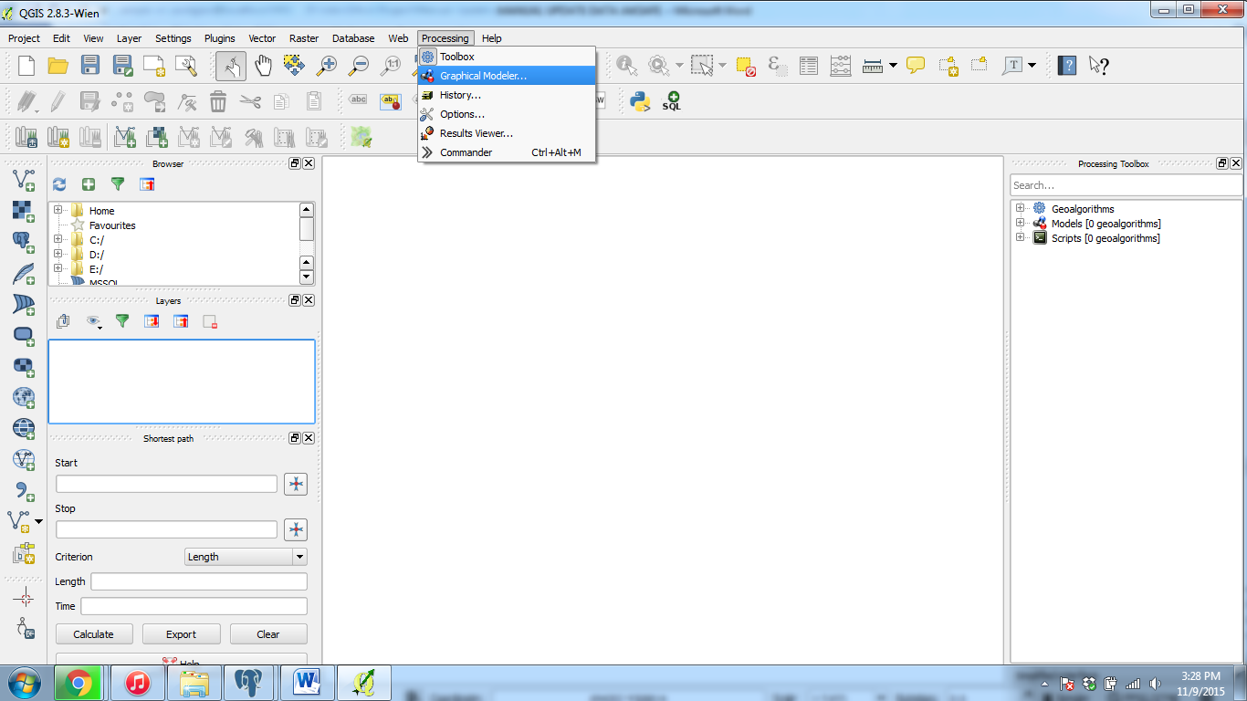

1. Click processing

2. Choose graphical modeler

Figure 14 Open Graphical Modeler

* Then on the **processing modeler window > open file model** ***js_building.model***

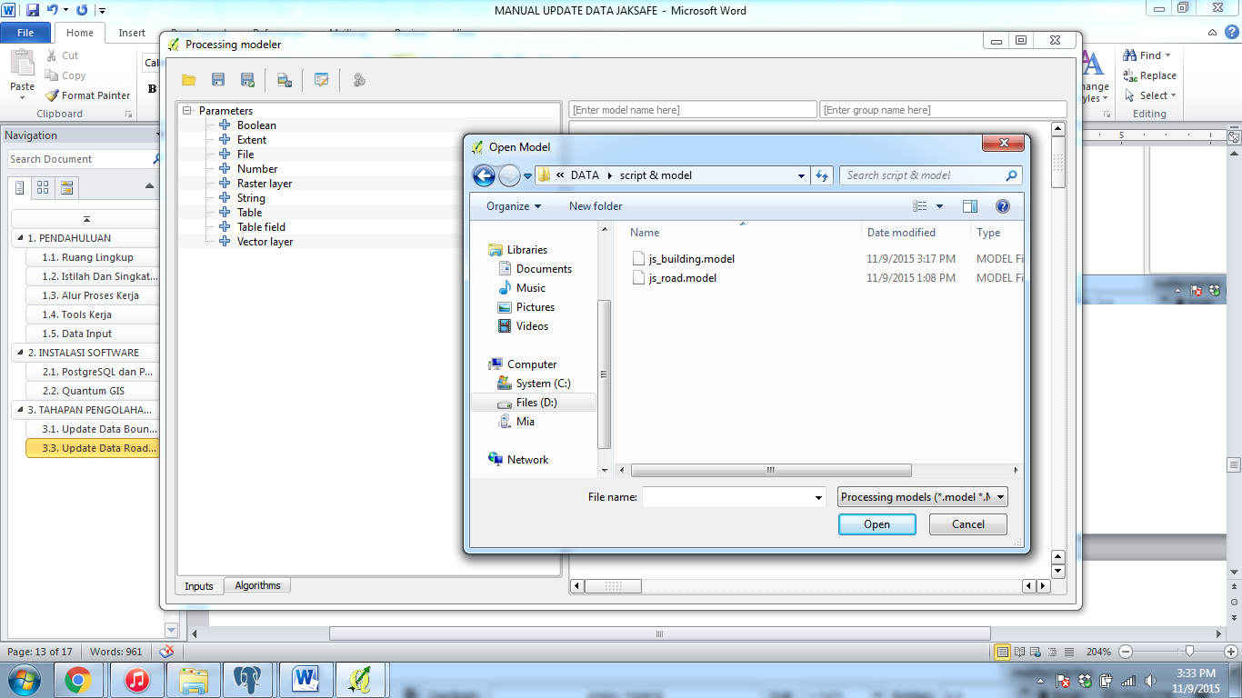

2. Browse file js_building.model

1. Click open

Figure 15 Open Model

* Then browse ***hazard.shp*** in hazard column and ***building_exposure.shp*** building_exposure column > click ***RUN MODEL***

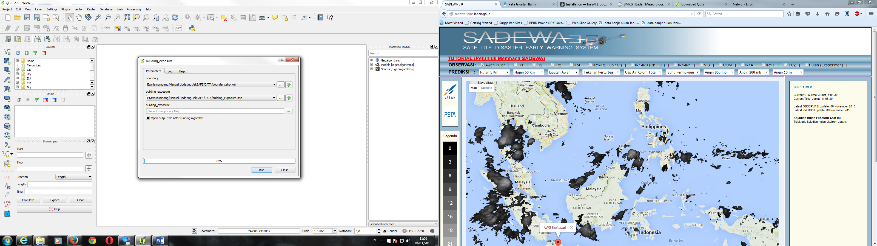

3. Run Model

1. Masukan file hazard.shp

2. Masukan file building_exposure.shp

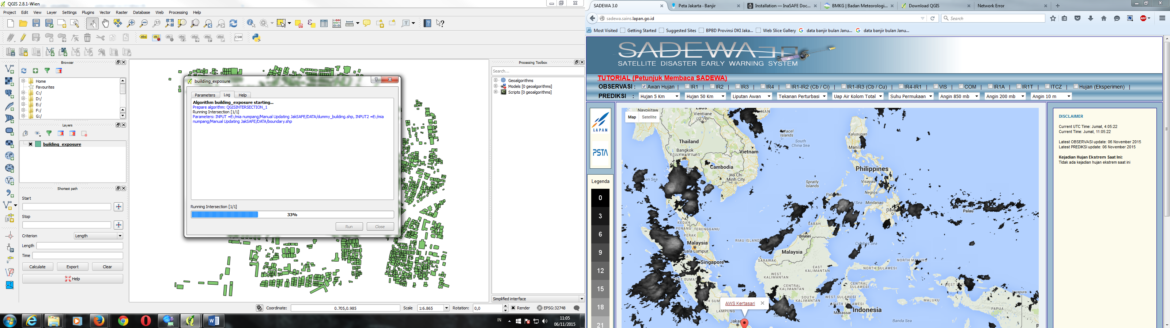

Figure 16 Running Model

* The output of those process will go into PostGIS database (in my case it is postgis_21_sample database) in table named building_exposure, so go to **PgAdmin > Postgres 9.2 > postgis_21_sample** and find building_exposure table in it. However the output need to be cleansed before deployed into JakSAFE database. So we need to run js_building.sql script to cleansed the database.

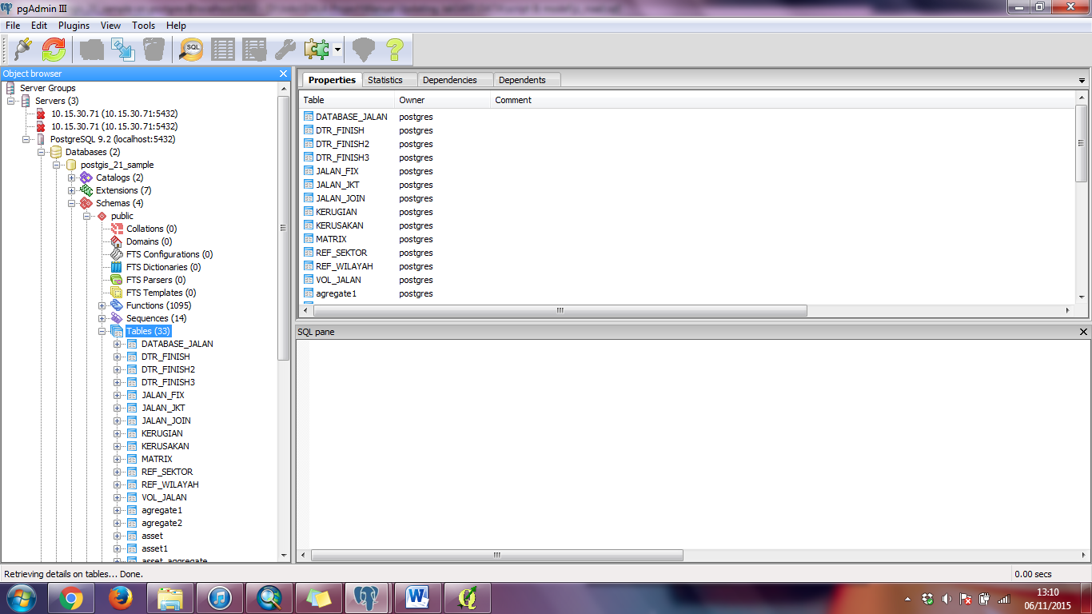

1. Choose the Scheme and Table
2. Choose Toolbar **Execute Query**
3. Choose Database
4. Click PostgreSQL

Figure 17 Open Database

* Choose **Open FILE** >> Select script **js_building.sql** to cleanse the database

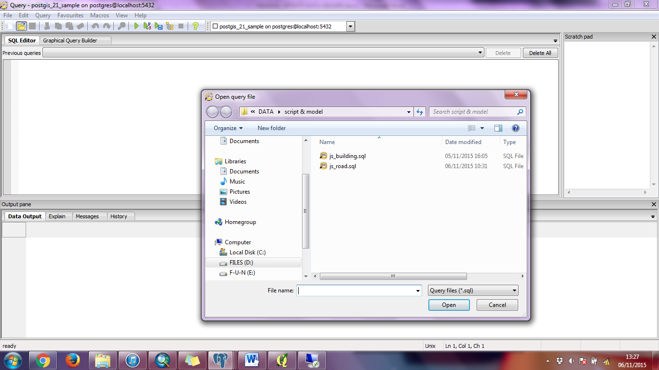

1. Open file **js_building.sql**
2. Click Toolbar **Open File**

Figure 18 Open Database Script

* After opening the script, execute it by choosing Toolbar **Execute Query**

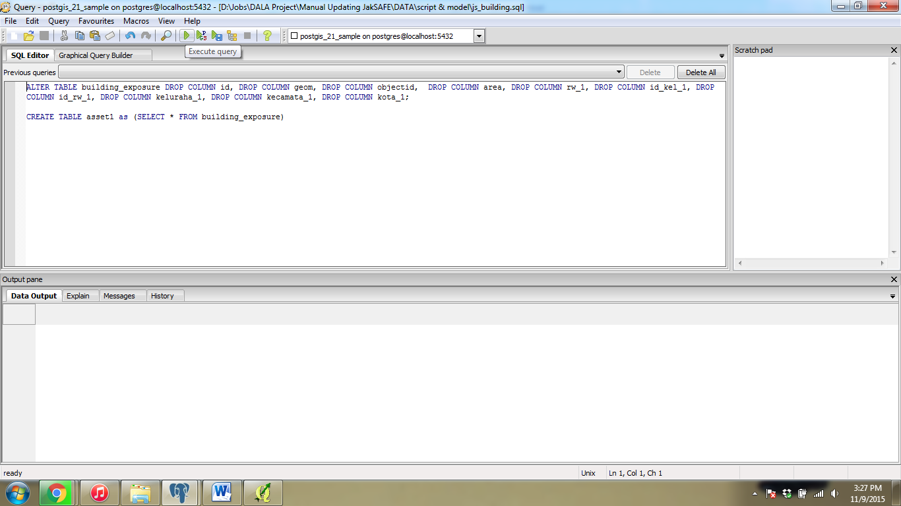

Klik Toolbar ***Execute Query***

Figure 19 Execute Query

* And the process of database cleansing is done, and table is ready to deployed into server by backuping the table. Backup table can be done by right clicking desired tabl (asset) >> then choose ***Backup***

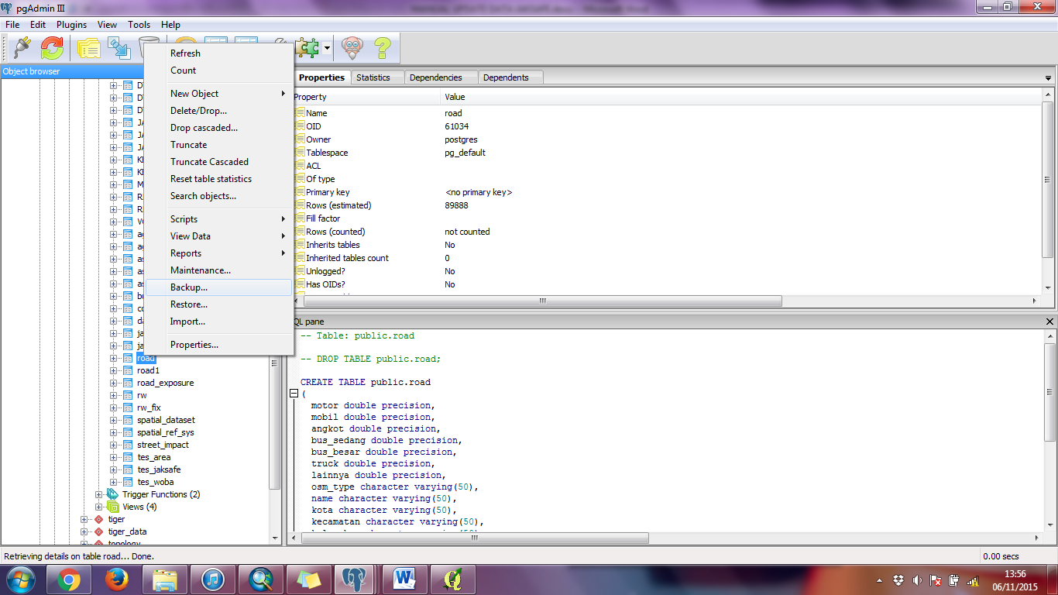

Choose backup

Figure 20 Backup FIle

* Before backup the file, set the setting of the file like this one > then click **Backup.** Save name of this database into asset.backup

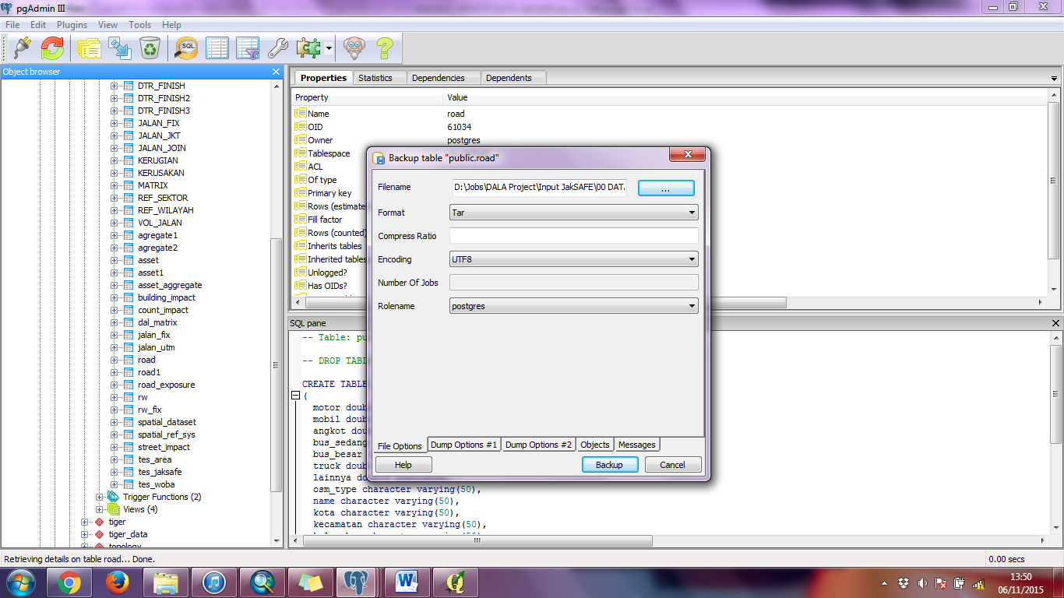

1. Choose **saving *directory***
2. Choose ***Custom***
3. Chose ***UTF8***
4. Choose ***postgres***
5. Run ***Backup***

Figure 21 Run Backup

## Road Exposure

The steps that has to be done to updating exposure data based on hazard data are:

* Open QGIS Software, then click **Add Vector Layer > and browse** ***hazard.shp dan road_exposure.shp > Then click open***



Add vector layer

Figure 22 Add Vector Layer

* Then on Menu bar, open ***PROCESSING*** > ***GRAPHICAL MODELER***



1. Click processing

2. Choose graphical modeler

Figure 23 Open Graphical Modeler

* Then on the **processing modeler window > open file model** ***js_road.model***



1. Click open

2. Browse file js_road.model

Figure 24 Open Model

* Then browse ***hazard.shp*** in hazard column and ***road_exposure.shp*** building_exposure column > click ***RUN MODEL***

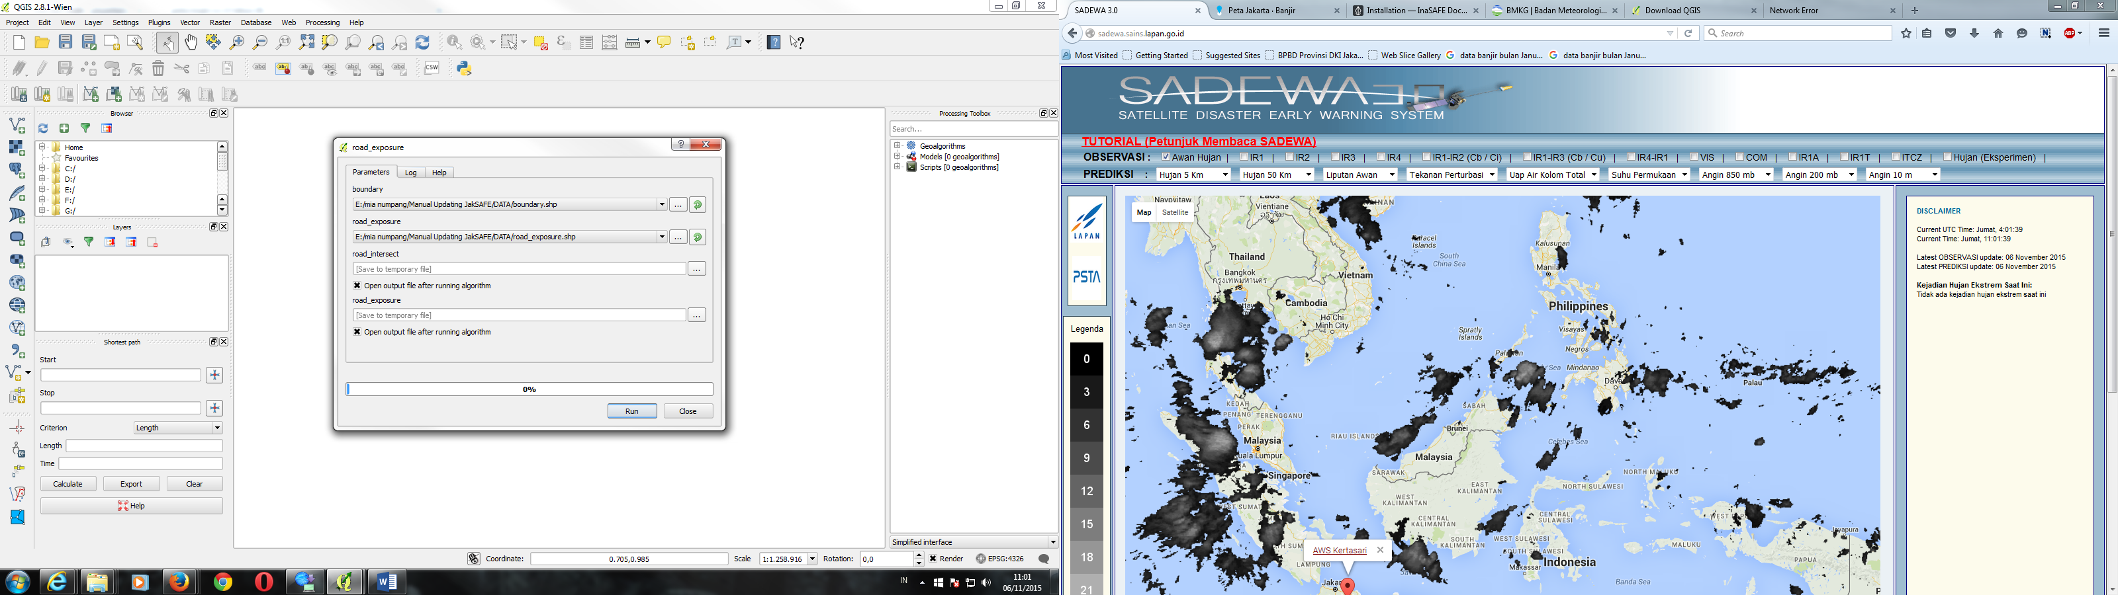

3. Run Model

1. Masukan file hazard.shp

2. Masukan file road_exposure.shp

Figure 25 Run Model

* The output of those process will go into PostGIS database (in my case it is postgis_21_sample database) in table named road_exposure, so go to **PgAdmin > Postgres 9.2 > postgis_21_sample** and find road_exposure table in it. However the output need to be cleansed before deployed into JakSAFE database. So we need to run js_road.sql script to cleansed the database.



1. Choose the Scheme and Table
2. Choose Toolbar **Execute Query**
3. Choose Database
4. Click PostgreSQL

Figure 26 Open Database

* Choose **Open FILE** >> Select script **js_road.sql** to cleanse the database



1. Open file **js_road.sql**
2. Click Toolbar **Open File**

Figure 27 Open Database Script

* After opening the script, execute it by choosing Toolbar **Execute Query**



Klik Toolbar ***Execute Query***

Figure 28 Executing Query

* And the process of database cleansing is done, and table is ready to deployed into server by backuping the table. Backup table can be done by right clicking desired tabl (asset) >> then choose ***Backup***



Choose backup

Figure 29 Backup Table

* Before backup the file, set the setting of the file like this one > then click **Backup.** Save name of this database into road.backup



1. Choose **saving *directory***
2. Choose ***Custom***
3. Chose ***UTF8***
4. Choose ***postgres***
5. Run ***Backup***

Figure 30 Run Backup

1. Making Database

# Data

The final step is to populate all of the data into the database. You need to prepare the following data and download some additional:

Table 6 Data for Deploying Database

|  |  |  |  |
| --- | --- | --- | --- |
| **Data** | **File Name** | **Description** | **Source/Download Link** |
| Building exposure database | asset.backup | Output from building exposure process | *(the result of* |
| Road exposure database | road.backup | Output from road exposure process |  |
| Aggregate exposure of JakSAFE | asset_aggregate.csv |  | https://github.com/geoenvo/jaksafe-etc/blob/master/asset_aggregate.csv |
| Damage and loss matrix | dal_matrix.csv |  | https://github.com/geoenvo/jaksafe-etc/blob/master/dal_matrix.csv |
| Vehicle damage and loss assumption | asumsi_dal_kendaraan.csv |  | https://github.com/geoenvo/jaksafe-etc/blob/master/asumsi_dal_kendaraan.csv |
| Script SQL for precalculation | script_precalc.sql |  | https://github.com/geoenvo/jaksafe-etc/tree/master/query_database |
| Script SQL for precalculation aggregate data | script_precalc_agg.sql |  | https://github.com/geoenvo/jaksafe-etc/tree/master/query_database |
| Script SQL for making main table | making_table.sql | For making asset_aggregate, asumsi_kendaraan, and dal_matrix table | https://github.com/geoenvo/jaksafe-etc/tree/master/query_database |

# JakSAFE Database Struchture

# Before deploying the data, you need to understand table struchture in JakSAFE database, it can drilled down into three kindsof table, they are:

Table 7 Database Struchture

|  |  |
| --- | --- |
| Database | Description |
| Main table | is table generated either from hazard data, exposure data, or assumption data. Main table in JakSAFE are:assetasset_aggregateroaddal_matrixasumsi_kendaraan |
| Precalculation table | is table generated from main database but has been processed by *script_precalc.sql* before to faster DaL calculation process. Precalculation table in JakSAFE are:asset_rw_unitasset_rwasset_rw_kelasasset_rw_jalanasset_jalan_kelaskendaraan_rwkendaraan_rw_lossasset_rw_dalkendaraan_rw_kelas |
| Table auto | is automatic table that doesn’t have to be updated |

## Deploy Main Database

# To deploying database, we need to connecting our localhost PostgreSQL to server connection (production server) with steps like follow:

# Choose add connection server toolbar from your PostgreSQL

# 

Choose Add connection to a server

Figure 31 Add PostgreSQL Server Connection

# Then in *New Server Registration* details, fill the detail of server connection, and don’t forget to fill the username and password of your production server

# 

Figure 32 Setting Server Connection

* Then file backup of main database can be restored with **right clicking in the scheme database > then choose** ***Restore***

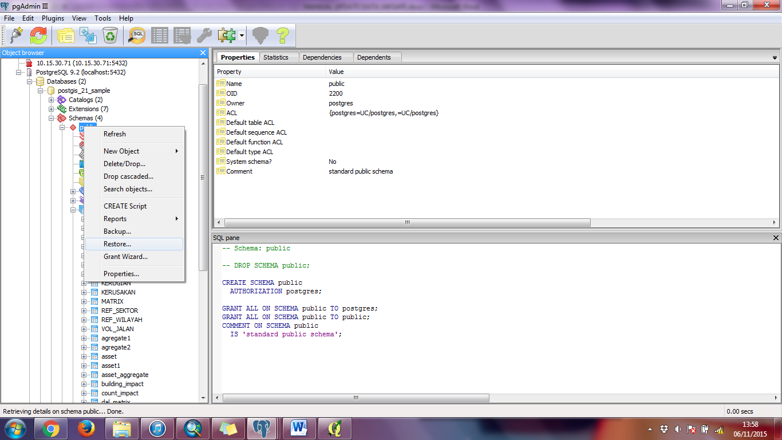

Right click the scheme, and click Restore

Figure 33 Restore Database in Server

* Then choose file settings like below >> and click restore afterwards

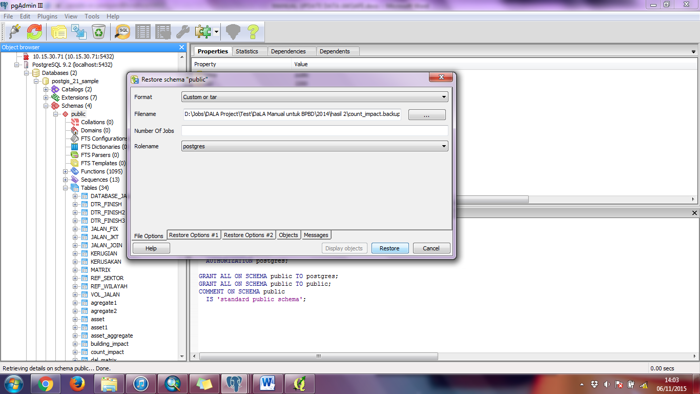

1. Choose **Custom or tar**
2. Open file **road.backup**
3. Choose **postgres**
4. Run **Restore**

Figure 34 Run Restore

* Do all those steps above for asset,backup and road.backup
* While for asset that is in csv format (asset_aggregate, dal_matrix, and asumsi_kendaraan), make the table on the database by running making_table.sql (with steps like before)
* After that, import the csv file by **right clicking the** **destined table > select the csv file > select format file > and choose Import**

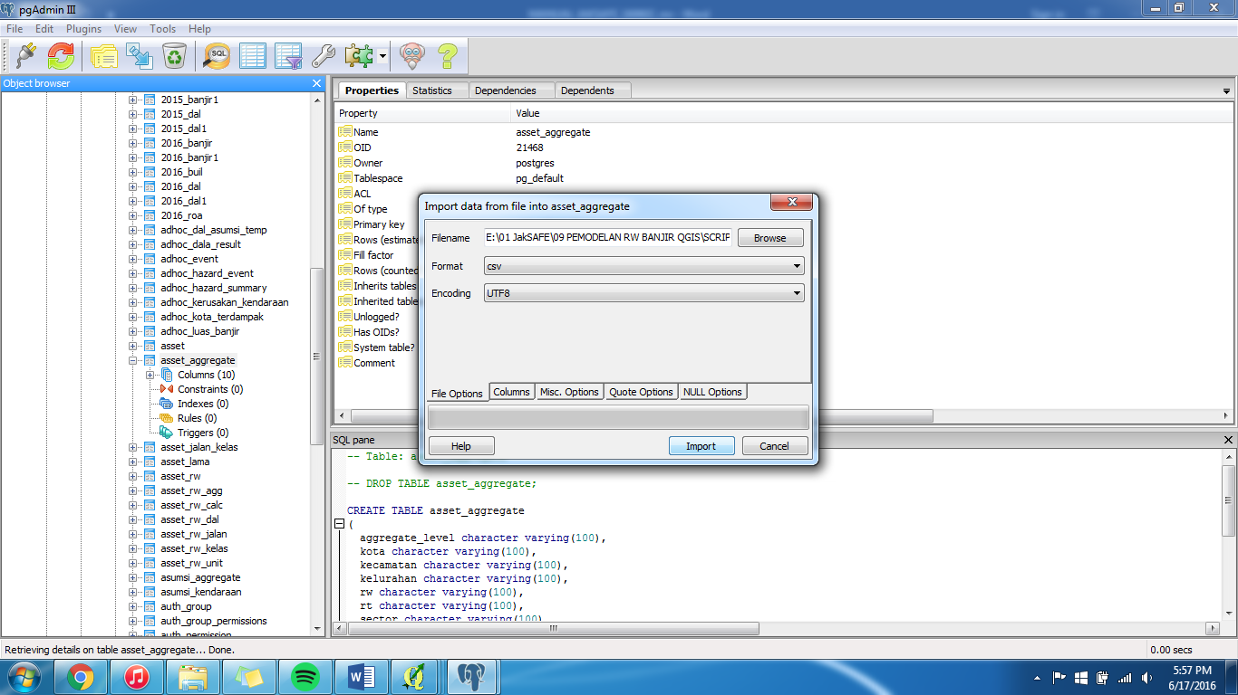

3. Click import

2. Choose csv format

1.Choose csv file

Figure 35 Import CSV

## Pre Calculation Database

# Now that main database is already on the production server, run script for precalculation. The steps is still the same like before, you just need to download the script and run it in the following oder:

# script_precalc_agg.sql

# script_preclac.sql